Packet Tracer Skills Assessment

Name: ___Shazia Bano Patel_____ Section: __________ Date: ___10/2/2024____

Initial Guidance and Instructions
Use this document to complete the Hand-On Final, a Packet Tracer activity. Please carefully read and fully understand this entire document before you start.

1. For this Activity, you will upload two files.

- This instructions file with all tables filled in.
- The completed Packet Tracer file.

2. Complete the IPv4 VLSM Design portion outlined further below including filling out the VLSM table in this document on page 5.

3. Verify your VLSM design results in Blackboard.

Blackboard > Assignments > Module 18 > HOF > HOF Verify

You must score 100 before the HOF PT file becomes available for download.

4. Once you score 100 in the previous step, download the Packet Tracer file from BB:

Blackboard > Assignments > Module 18 > HOF > HOF Download

Again, it will not become available until you score 100 on your VLSM design verification in BB.

5. Complete the Packet Tracer using the requirements specified in the instructions further below.

- Ensure you enter your name and date in the User Profile, or no credit will be given.

6. Upon completion, upload both, this file, and the completed Packet Tracer file via Blackboard for grading:

Blackboard > Assignments > Module 18 > HOF > HOF Upload

Assessment Objectives
- VLSM Subnetting
- IPv4 Addressing
- IPv6 Addressing
- Device Configuration
- Device Hardening

Tips
- In this activity you will configure devices as specified in the steps outlined in this document.

- To help ensure you are on track, verity the Percent Completion indicator is in the vicinity of the value specified at the end of every section.

- If the Percent Completion indicator is much less than expected, use the show run command and look for errors in the section just configured. Alternatively, make a note of it, move on, then debug later.

- Observe case, spelling, and punctuation as needed.

- Every command entered will not necessarily yield and increase in the Percent Completion indicator.

- Supporting documents for the subnetting portion can be found in:

Blackboard > Resources > Subnetting

Topology

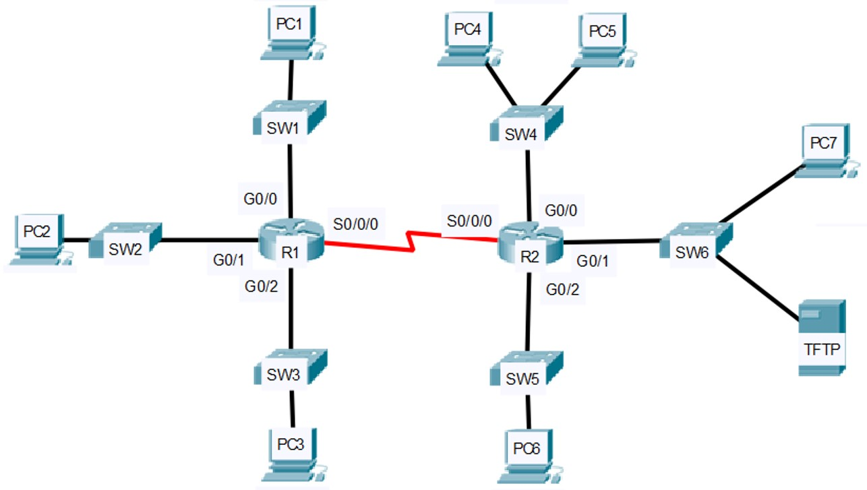

IPv6 Addressing Table
Device | Interface | IPv6 Address | Link-Local | Default Gateway
R2 | G0/0 | 2001:DB8:FADE:A::1/64 | FE80::2 | N/A
 | G0/1 | 2001:DB8:FADE:B::1/64 | FE80::2 | N/A
PC4 | NIC | 2001:DB8:FADE:A::10/64 | FE80::A | FE80::2
PC5 | NIC | 2001:DB8:FADE:A::15/64 | FE80::B | FE80::2
PC7 | NIC | 2001:DB8:FADE:B::10/64 | FE80::A | FE80::2
TFTP | NIC | 2001:DB8:FADE:B::15/64 | FE80::B | FE80::2

IPv4 VLSM Design
Design an IPv4 addressing scheme and complete the addressing table on the next page based on the requirements listed.
NOTE: You must fill out the VLSM worksheet on the next page to receive credit.

Subnet the 172.16.0.0/16 address space using VLSM based on the number of host addresses needed in the topology as follows:

- SW1 LAN requires 30 hosts.
- SW2 LAN requires 30 hosts.
- SW3 LAN requires 30 hosts.
- SW4 LAN requires 30 hosts.
- SW5 LAN requires 14 hosts.
- SW6 LAN requires 14 hosts.

Subnetting Worksheet - VLSM Starting/Given Address: ________________

Subnet  Name | Hosts  Required | Host  Bits  ( h ) | Number  of Usable  Addresses  ( 2^{h} - 2 ) | CAM or PAM, and CSM  Optional: WCM and Prefix | Interval  / Octet | Network Address / Prefix Len
SW1  LAN | 30 | 5 | 30 | PAM: N.N.N.xxshhhhh  CSM: 255.255.255.224  WCM: 0.0.0.31  Prefix: /27 | 32, 4th | NTWK: 172.16.0.0/27  FRST: 172.16.0.1  LAST: 172.16.0.30  BCST: 172.16.0.31
SW2  LAN | 30 | 5 | 30 | PAM: N.N.N.xxshhhhh  CSM: 255.255.255.224  WCM: 0.0.0.31  Prefix: /27 | 32, 4th | NTWK: 172.16.0.32/27  FRST: 172.16.0.33  LAST: 172.16.0.62  BCST: 172.16.0.63
SW3  LAN | 30 | 5 | 30 | PAM: N.N.N.xxshhhhh  CSM: 255.255.255.224  WCM: 0.0.0.31  Prefix: /27 | 32, 4th | NTWK: 172.16.0.64/27  FRST: 172.16.0.65  LAST: 172.16.0.94  BCST: 172.16.0.95
SW4  LAN | 30 | 5 | 30 | PAM: N.N.N.xxshhhhh  CSM: 255.255.255.224  WCM: 0.0.0.31  Prefix: /27 | 32, 4th | NTWK: 172.16.0.96/27  FRST: 172.16.0.97  LAST: 172.16.0.126  BCST: 172.16.0.127
SW5  LAN | 14 | 4 | 14 | PAM: N.N.N.xxxshhhh  CSM: 255.255.255.240  WCM: 0.0.0.15  Prefix: /28 | 16, 4th | NTWK: 172.16.0.128/28  FRST: 172.16.0.129  LAST: 172.16.0.142  BCST: 172.16.0.143
SW6  LAN | 14 | 4 | 14 | PAM: N.N.N.xxxshhhh  CSM: 255.255.255.240  WCM: 0.0.0.15  Prefix: /28 | 16, 4th | NTWK: 172.16.0.144/28  FRST: 172.16.0.145  LAST: 172.16.0.158  BCST: 172.16.0.159
 |  |  |  | PAM:  CSM:  WCM:  Prefix: |  | NTWK: 172.16.0.160  FRST:  LAST:  BCST:

IPv4 VLSM Address Assignment
Assign addresses according to the requirements below. Refer to entries in the VLSM worksheet on the previous page.

Use the following information to fill out the table below as needed.
- Assign the 1st usable address from the SW4 LAN subnet to interface G0/0 on router R2.
- Assign the 2nd usable address from the SW4 LAN subnet to SW4.
- Assign the 3rd usable address from the SW4 LAN subnet to PC4.
- Assign the last usable address from the SW4 LAN subnet to PC5.
- Assign the 1st usable address from the SW6 LAN subnet to interface G0/1 on router R2.
- Assign the 2nd usable address from the SW6 LAN subnet to PC7.
- Assign the last usable address from the SW6 LAN subnet to the TFTP server.

LAN | Device | Interface | Address to Assign | IPv4 Address
 | R2 | G0/0 | 1st Usable | 172.16.0.97
SW4  Subnet | SW4 | VLAN1 | 2nd Usable | 172.16.0.98
 | PC4 | NIC | 3rd Usable | 172.16.0.99
 | PC5 | NIC | Last Usable | 172.16.0.126
 | R2 | G0/1 | 1st Usable | 172.16.0.145
SW6  Subnet | PC7 | NIC | 2nd Usable | 172.16.0.146
 | TFTP  Server | NIC | Last Usable | 172.16.0.158

IPv4 Addressing Table
Use the information from the previous section to construct the addressing table below. When making your entries please do not do this: 172.16.0.__250___
Instead, simply double click the line, and immediately start typing so you end up with entries that look like this: 172.16.0.250

Device | Interface | IPv4 Address | Subnet Mask | Default Gateway
R2 | G0/0 | 172.16.0.97 | 255.255.255.224 | N/A
 | G0/1 | 172.16.0.145 | 255.255.255.240 | N/A
SW4 | VLAN1 SVI | 172.16.0.98 | 255.255.255.224 | 172.16.0.97
PC4 | NIC | 172.16.0.99 | 255.255.255.224 | 172.16.0.97
PC5 | NIC | 172.16.0.126 | 255.255.255.224 | 172.16.0.97
PC7 | NIC | 172.16.0.146 | 255.255.255.240 | 172.16.0.145
TFTP | NIC | 172.16.0.158 | 255.255.255.240 | 172.16.0.145

ATTENTION: VLSM PROGRESS CHECK
Before proceeding and before configuring any
devices, verify your VLSM design by entering your results in:
Blackboard > Assignments > Module 18 > HOF > HOF Verify
You must score 100 or you will not be able to download the corresponding PT file.
Once you score 100 the PT file will become available for download in:
Blackboard > Assignments > Module 18 > HOF > HOF Download
Download the PT file and proceed to the next page.

Configure Router R2
Part 1: Basic Configuration on R2 (Completion: 11%)
- Configure the router name: R2
- Disable DNS lookup
- Secure access to the Privilege EXEC mode using an encrypted password: ciscocisco
- Invoke the service to encrypt all passwords
- Add a message of the day banner: Unauthorized Access Prohibited!
- Enable IPv6 routing on R2
- Require all passwords to contain at least 10 characters

Part 2: Basic Console Configuration on R2 (Completion: 15%)
- Access the console line
  - Enable messages to be logged synchronously
  - Do not timeout/close connection if idle
  - Configure the console password: ciscocisco
  - Require the user to enter the password to login

Part 3: Basic VTY Configuration on R2 (Completion: 18%)
- Access the first 5 VTY lines on R2
  - Enable messages to be logged synchronously
  - Do not timeout/close connection if idle
  - Configure the VTY password: ciscocisco
  - Require the user to enter the password to login

Part 4: Configure G0/0 on R2 (Completion: 29%) 30???
- Access interface G0/0
- Include the description: Link to SW4
- Configure the IPv4 address and subnet mask determined via VLSM
- Configure the IPv6 global unicast address given
- Configure the IPv6 link-local address given
- Activate the interface

Part 5: Configure G0/1 on R2 (Completion: 39%)
- Access interface G0/1
- Include the description: Link to SW6
- Configure the IPv4 address and subnet mask determined via VLSM
- Configure the IPv6 global unicast address given
- Configure the IPv6 link-local address given
- Activate the interface

Part 6: Configure R2 for Remote Management Over SSH (Completion: 47%)
- Create a username netadmin with the highest privilege level and encrypted password: ciscocisco
- Configure a domain name: ccna.com
- Generate RSA keys with a modulus of 1024
- Access the first five VTY lines
  - Specify SSH as the transport mechanism to access the VTY lines
  - Require the user to login using the credentials in the local username database.

Configure Switch SW4

Part 7: Configure SW4 (Completion: 58%)
- Configure the switch hostname: SW4
- Disable DNS lookup
- Configure the default gateway
- Access the VLAN1 SVI (Switch Virtual Interface)
  - Configure the VLAN1 IPv4 address and subnet mask determined via VLSM
  - Activate the SVI

Part 8: Secure Access to SW4 and Save Config (Completion: 69%)
- Access the console line
  - Log messages synchronously
  - Do not timeout/close connection if idle.
  - Configure the console password: ciscocisco
  - Require the user to enter the password to access

- Access all the VTY lines
  - Log messages synchronously
  - Do not timeout/close connection if idle
  - Configure the VTY password: ciscocisco
  - Require the user to enter the password to login

- Save the running configuration to NVRAM

Configure PCs and TFTP Server
Part 9: Configure IPv4 Addresses for PCs and TFTP server (Completion: 81%)
- PC4: Configure the IPv4 address, subnet mask and default gateway
- PC5: Configure the IPv4 address, subnet mask and default gateway
- PC7: Configure the IPv4 address, subnet mask and default gateway
- TFTP: Configure the IPv4 address, subnet mask and default gateway

Part 10: Configure IPv6 Addresses for Devices in the SW4 LAN (Completion: 89%)
- PC4: Use the information in the IPv6 Addressing Table to configure the following:
  - Unicast routing address and prefix
  - Link-local address
  - Default gateway

- PC5: Use the information in the IPv6 Addressing Table to configure the following:
  - Unicast routing address and prefix
  - Link-local address
  - Default gateway

Part 11: Configure IPv6 Addresses for Devices in the SW6 LAN (Completion: 97%)
- PC7: Use the information in the IPv6 Addressing Table to configure the following:
  - Unicast routing address and prefix
  - Link-local address
  - Default gateway

- TFTP: Use the information in the IPv6 Addressing Table to configure the following:
  - Unicast routing address and prefix
  - Link-local address
  - Default gateway

Part 12: Save and Backup the Config on R2 (Completion: 100%)
- Access router R2.
- Save the running configuration to NVRAM
- Copy the running configuration of R2 to the TFTP server using “R2-confg” (w/o quotes) as the name of the destination file.

